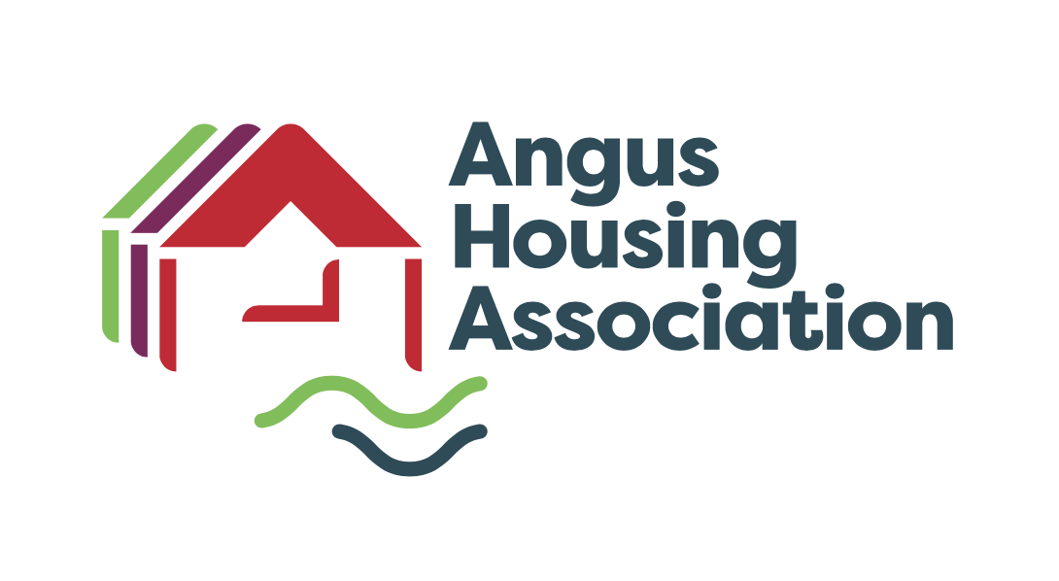

Policy Name |  | Welfare and Financial Inclusion Strategy
Policy Ref |  | HM
Review Date |  | July 2023
Purpose |  | REVIEW & APPROVE
Next Review Date |  | July 2027
Committee |  | Committee of Management
Author |  | Linlay Anderson
Internal Policy |  | To be published | X

Angus Housing Association Limited Registered Charity Number SC020981

Charter Outcomes | Number(s)
The Customer/landlord relationship | - Equalities  - Communication  - Participation

Housing quality and maintenance

Neighbourhood and community
Access to housing and support | 7, 8, 9 & 10

Getting good value from rents and service charges

Written By | Linlay Anderson
Department | Housing Management

Approval Date by Committee

Notes

Policy drawn up with reference to:

Housing (Scotland) Act 2001
Housing (Scotland) Act 2014
Civil Partnership Act 2004
Data Protection Act 1998
Social Housing Charter 2012, Reviewed 2016, 2021 Social Housing Charter 2022

This policy was originally approved on December 2008
This policy was reviewed at Committee on 2 May 2012, 14 March 2018, October 2019

ANGUS HOUSING ASSOCIATION LIMITED

Welfare and Financial Inclusion Strategy 2023 - 2027

- Introduction

The purpose of this strategy is to promote financial inclusion, maximise income and welfare benefits, and improve the financial well-being of our tenants who face financial difficulties or social exclusion. By ensuring better access to welfare benefits, money management, and debt advice services and resources, our aim is to support our tenants to manage their household finances and to sustain tenancies.

The Association will also ensure tenants and applicants are aware of Social Security Scotland witch is an Executive Agency of the Scottish Government responsible for managing the benefits that are devolved to Scotland.

- Aims and Objectives

It is important the Associations values are established in the strategy -

- Demonstrating Social Values
- Putting Customers First
- Respect
- Embracing Innovation & Adaptability

Our aims and objectives are to –

- Ensure our tenants have access to information, advice and support on welfare benefits, money management and debt advice services and resources to maximise their income, reduce their expenditure and reduce their debt.

- Assist our tenants to deal with financial issues, such as rent arrears or other debts, by providing support and advice on the range of options and best methods to address and resolve those issues.

- Work with partners to develop and provide tailored services to support tenants who are facing severe financial difficulties, such as temporary financial assistance, discretionary housing payments or targeted advice and recoverable loans.

- Provide training and support to our staff to ensure that they are appropriately trained to identify and support tenants with financial difficulties, and that they are equipped with the relevant skills and knowledge to provide effective advice and support.

- Purpose

The purpose of this strategy is to provide a positive impact on the lives of our tenants by providing excellent financial and welfare advice. By achieving this the Association can work towards -

- Prevent Rent Arrears
- Maximising Tenants Income
- Preventing expensive court actions and evictions
- Promote tenancy sustainment and prevent homelessness
- Build good working relationships with stakeholders
- Support community stability

- Designing services to meet Tenant needs

The vast majority of our tenants understand the importance of paying rent and know the Association needs to collect rental income. Some tenants do have difficulties in paying bills and managing their finances.

In order for the Association to deliver excellence, it is recognised that the service needs to be tailored around tenants’ needs and expectations which include but are not limited to:

- Carrying out a financial viability interview and provide information housing benefit and Universal Credit information and advice.
- The Association has developed a Tenancy Sustainment Policy and Procedures. This includes a Applicant Home Visit Checklist for all new tenants to identify any financial or support needs required in order for the applicant to maintain their tenancy.
- Making it easy to pay rent by various methods to suit their needs.
- Contact at an early stage before rent arrears have reached higher levels.
- Working closely with Dundee City and Angus local authority Housing Benefit Teams to resolve problems quickly.
- Association will deliver services to meet tenants’ needs.
- Work closely with DWP and build good working relationships with local Job Centres.

- Delivery of Strategic Aims

The strategy will align the activity of the Association to achieve the best customer and business outcomes on rent payment and debt collection by:

- Ensuring our tenants are aware of the support and resources available to them through effective communication methods such as Social media (Facebook), leaflets and newsletters
- Redesigning our rent and letting processes to streamline activities and improve efficiency. Expanding our payment opportunities to suit customer needs.
- Providing the best and earliest support to tenants, new and existing, to ensure they understand and can deliver on their financial obligation to Angus Housing Association.
- Having skilled and knowledgeable front line staff to support tenancy sustainment.
- Improving the range of rent, debt support and advice options that are available either directly through our organisation, or by signposting to other agencies.
- Taking early action if things go wrong.
- Personal contact (doorstep, phone, text) and avoiding standard letters wherever possible.
- Making use of all available remedies and using possession and eviction only as a last resort once all other reasonable steps have been taken.
- Developing joint working arrangements with our partners at Angus and Dundee City local authority’s to maximise benefit opportunities.
- Developing joint working arrangements with DWP and local Job Centers.
- Being determined and successful in income collection and the recovery of debts owed.
- Providing value for money by focusing on protecting income and ensuring resources are used effectively.

- Delivering and Implementing the Strategy

Establish partnerships with relevant stakeholders and organisations such as the Citizens Advice Bureau, Money Advice Scotland, and the Scottish Welfare Fund to provide tenants with access to welfare benefits, debt advice and related services.

Provide online and face-to-face resources to support tenants to understand and maximise their income, including access to benefit calculators and information on local welfare agencies and support services.

- Advice & Training

Advice and Training for staff is paramount if we are to support tenants through the impact of welfare reform and provide a professional service. This can only be achieved by:

- Identifying and accessing appropriate external training for staff when available
- Fully utilising the services of the Financial Inclusion Officers
- Regularly briefing all front line staff of changes.
- Ensuring the Housing Management team is adequately resourced and that they have the skills to identify support needs that are putting or may put the tenancy at risk and engage with partner agencies to ensure a prompt response.
- Raising awareness of outside agencies and the role they can play

- SCOTTISH GOVERNMENT

Under the terms of the Scotland Act 2016, 11 benefits were devolved to the Scottish Government. Since May 2019 various benefits have been introduced to support people on low incomes, disabled people, carers, young people entering the workplace and help for people to heat their homes –

- Scottish Child Payment

Scottish Child Payment helps towards the costs of supporting your family. It's a weekly payment for every child who's under 16 years of age.

- Child Disability Payment

This is extra money every four weeks to help with the costs of caring for a child with a disability or ill-health condition. This payment replaces Disability Living Allowance for children in Scotland that was previously delivered by the DWP

- Carers Allowance Supplement

This is an automatic payment made twice a year to people in receipt of Carer’s Allowance.

- Young Carers Grant

This is an annual payment for people 16, 17 or 18 who care for people who get a disability benefit from the DWP for an average of 16 hours a week or more

- Job Start Payment

This is a one-off payment for 16 to 24 year olds who have been on certain benefits for six months or more to help with the costs of starting a job

- Winter Heating Payment

This is a new annual payment to help people on low income benefits who might have extra heating needs during the winter.

- Child Winter Heating Assistance

This is an annual payment made before March 31 to help families of a child on the highest rate care component of Disability Living Allowance for Children to heat their homes.

- Best Start Grant and Best Start Foods

Best Start Grant and Best Start Foods are payments that help towards the costs of being pregnant or looking after a child.

Best Start Grant is made up of 3 one-off payments:
  - Pregnancy and Baby Payment
  - Early Learning Payment
  - School Age Payment

Best Start Foods is a prepaid card that can be used in shops or online to buy healthy foods like milk or fruit. The payments you can get now will depend on:
- How far along in your pregnancy you are
- How old your child is

Best Start Grant and Best Start Foods are 2 separate payments but they can be apply for using the same form.
- Funeral Support Payment
Funeral Support Payment helps pay for funeral costs if you live in Scotland. You can use the payment towards funeral costs for a baby, child or adult. This includes babies who were stillborn.

- Equal Opportunities

The Association is committed to providing equality of opportunity to all persons or groups within its area of operations in every aspect of its activities. In operating this policy the Association will endeavour to ensure equality of opportunity for all at all times and in all circumstances. In line with this commitment to equal opportunities, this policy and any summary or information leaflet can be made available free of charge in a variety of formats including large print, translated into another language or on audio tape.

10. COMPLAINTS

The Association’s complaints/appeals procedure is open to everyone who receives or is requesting a service from the Association and people acting on their behalf.

11. Performance Reporting

The Service Delivery Sub Committee will receive a quarterly report analysis of the Association’s performance and identify any changes required. We will do this by:

- Using a range of indicators that will be used to report progress and performance including –

Number of referrals
Financial Gains

- Quarterly Hardship Fund Applications and spend
- Quarterly Case Studies

Some of the measures that will be put in place include:

- Monitoring against performance targets.
- Analysing trends in rent payment, collection and debt recovery.
- Undertaking monthly Financial Inclusion Satisfaction Surveys.

We are aware of the importance of feedback and will actively let tenants and stakeholders know how the Association is performing in relation to the management of debt and maximisation of rental income. This will be provided in a range of ways including, information given to resident group meetings, newsletters and website etc.

12. Monitoring and Review

This strategy will be reviewed on a four yearly basis and more frequently should circumstances require

Appendix 1
Welfare Reform – On Going Actions

Activity | Action
Migration of legacy benefits to Universal Credit. | The Housing Officers continue to identify tenants affected by the Under Occupancy charge. The Under Occupancy charge has been mitigated by the Scottish Government and currently any tenant affected by the charge can apply for a Discretionary Housing Payment (DHP).  The Financial Inclusion Officer (FIO) and Welfare Reform Officer (WRO) support tenants with Under Occupancy charges DHP claims.  The Association currently has 70 DHP cases in Angus and 71 DHP cases in Dundee. The DHP cases include Under Occupancy, Benefit Cap and those receiving Universal Credit.  However there may be tenants who are in receipt of DHP directly.
Raising awareness of on going and impending Welfare Reform changes through publications | Articles in Newsletter, Website posts on Social Media for example Facebook and Twitter.
Tenant Engagement | Roadshows and informal drop in sessions/cafes.

